Warehouse Management (WM)

Step 1: Create Purchase Order

Submit the screen shot of Create Purchase Order screen (2.5)

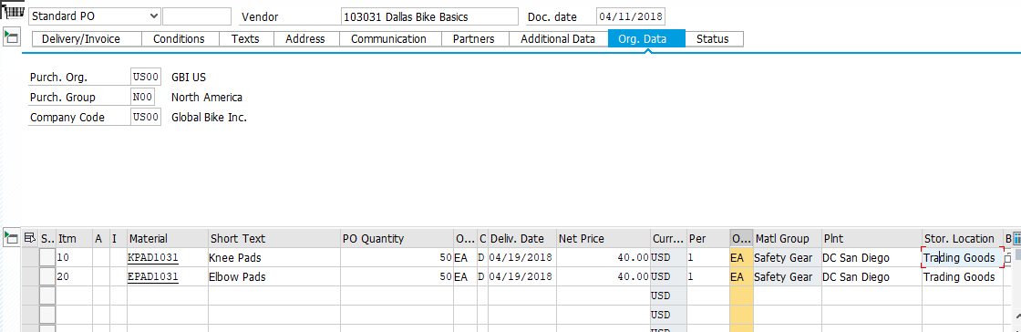

Record the purchase order number. You will need it later

4500000101

Step 2: Display Material Inventory

Submit the screen shot of Stock Overview: Basic List for EPAD1### (2.5 points)

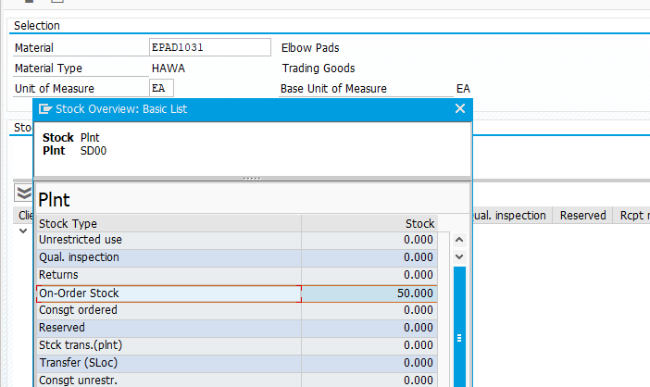

Step 3: Display Material Inventory Value

Submit the screen shot of Display Warehouse Stocks of Material for EPAD1### (2.5 points)

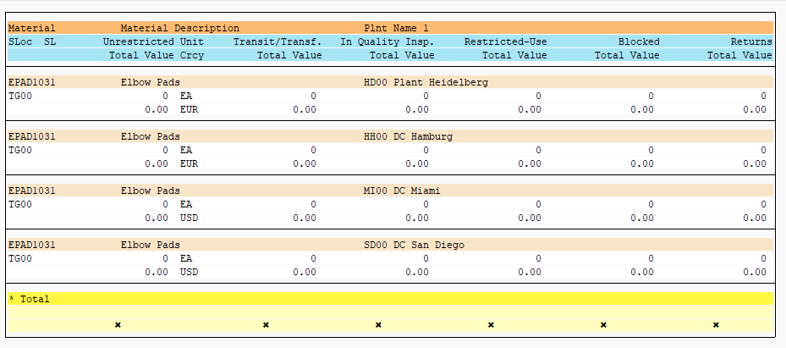

Step 4: Receive Goods

Submit the screen shot of General tab of the Goods Receipt (2.5 points)

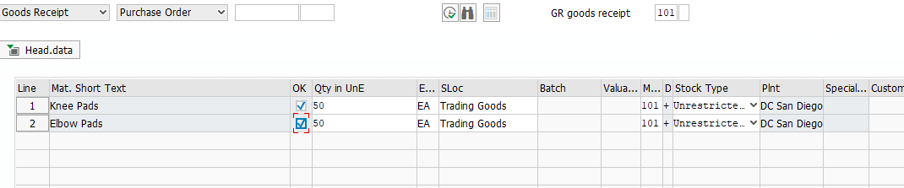

Record the material document number.

5000000210

Step 5: Display Material Inventory

Submit the screen shot of Stock Overview: Basic List for EPAD1### (2.5 points)

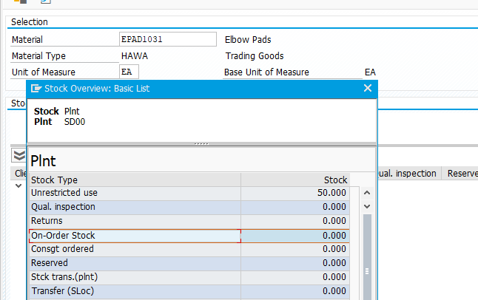

Step 6: Display Material Inventory Value

Submit the screen shot of Display Warehouse Stocks of Material for EPAD1### (2.5 points)

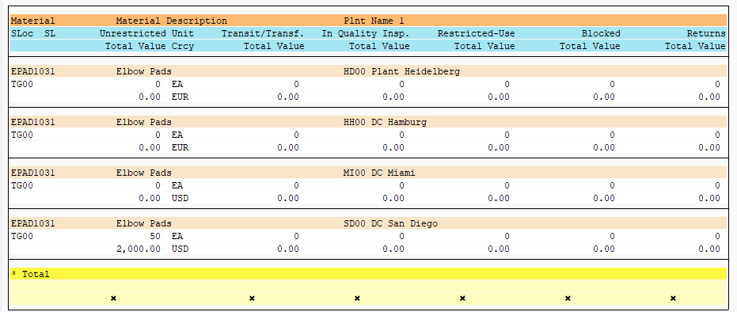

Step 7: Run Bin Status Report

Submit the screen shot of Bin Status Report: Overview (2.5 points)

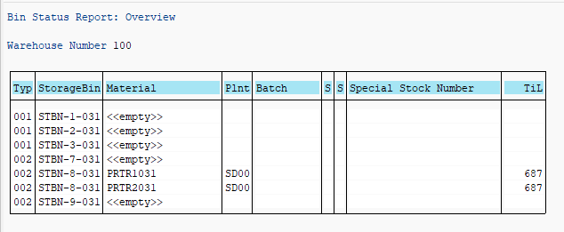

Step 8: Create Transfer Order

Submit the screen shot of Display Transfer Requirement: List For Material screen (2.5 points)

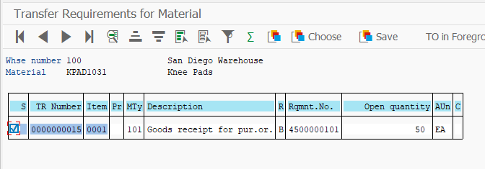

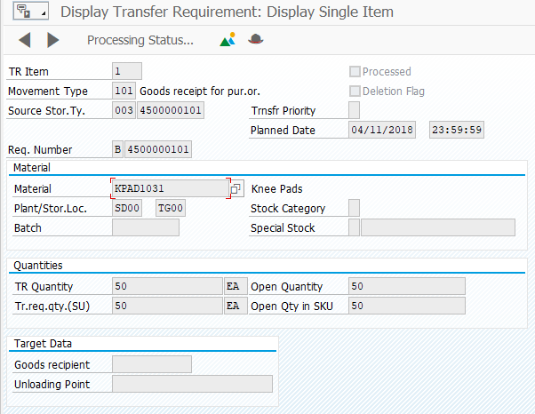

Submit the screen shot of Transfer Order: Prepare for Putaway screen for EPAD1### (2.5 points

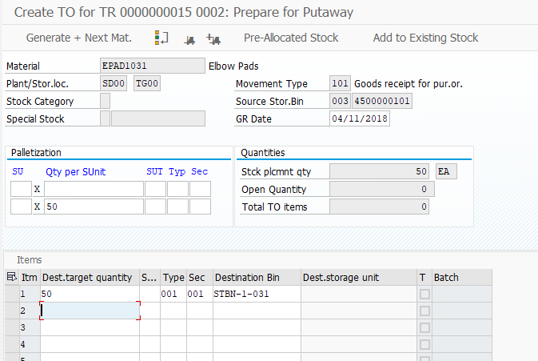

Please write down this number.

0000002063 :- EPADI031

Step 9: Confirm Transfer Order

Submit the screen shot of Confirm Transfer Order screen for EPAD1### (2.5 points)

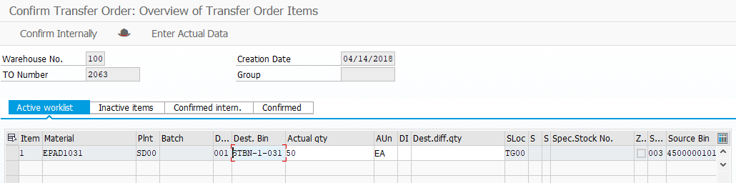

Step 10: Run Bin Status Report

Submit the screen shot of Bin Status Report: Overview screen (2.5 points).

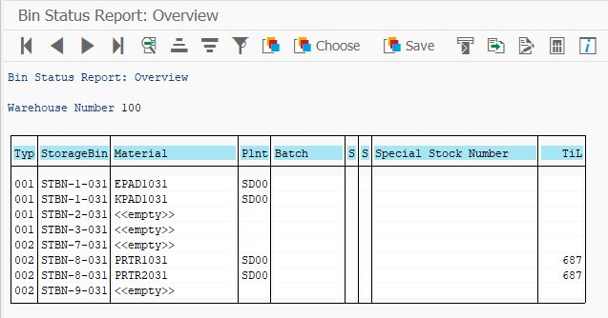

Submit the screen shot of Display Storage Bin (2.5 points

